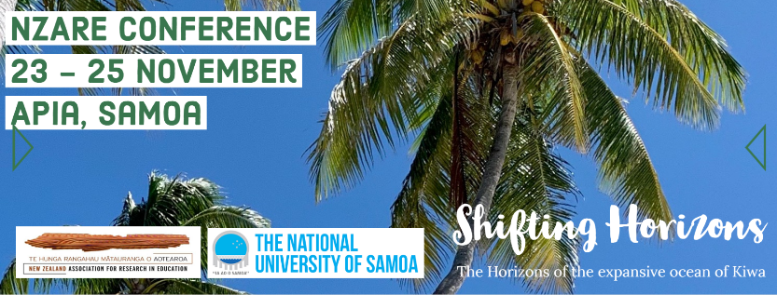

GUIDELINES FOR PRESENTATIONS
Conference Theme
Shifting Horizons - Our theme, Shifting Horizons, challenges researchers, educators and stakeholders to critically engage with questions about what we might need to change to ensure that our tamariki │ children │ tamaiti and rangatahi │ adolescents │ talavou are prepared for their future.
Deadline
The final call for papers ends on the 15 July 2020
Submission of Abstracts
- All titles, abstracts, keywords, authors and audiovisual (AV) requirements for any conference presentation are required by 15 July 2019.
- All abstracts have a word limit of 250 words (the word limit only includes the abstract. Title, name, biography etc. is not included in the word count).
- Abstracts are required to be submitted in Microsoft Word format (e.g. “.doc”).
- Abstracts must be submitted via the link on the NZARE website (https://www.nzare.org.nz/events/conference-2020/)
- Abstracts should contain:
- Objectives of the research
- Contemporary significance and/or scholarly relevance
- Perspective(s) or theoretical framework(s)
- Methods, techniques or models of inquiry
- Results and/or substantiated conclusions and/or key learnings to date
- This year we are doing a rolling acceptance process. This will speed up the rate at which we will return your submission.
- Authors are limited to two physical presentations at the conference. There is, however, no limit to the number of times they are listed as contributing (non-presenting) authors.
- On the word document submitted the person(s) must include all details below (please see page 4 for a template):
- Name(s)
- Title(s)
- Institute(s)
- Which Special Interest Group the presentation best falls under
- Biography
- Abstract

Presentation Types
Paper
- Papers are either classified as Completed or In-Progress. An In-Progress paper is one in which research / data collection is still ongoing and conclusions are still being formed
- Papers will be allocated into 25-minute sessions (20 minutes presentation & 5 minutes discussion).
Symposia
- A symposium is a collection of individual but associated papers, submitted separately but under one coordinator. Two to four papers can make up a symposium – three is probably ideal in a 90-minute concurrent session.
- Symposia can be a combination of completed and in-progress papers.
- A symposium will require:
- A cover title and corresponding abstract details of all presenting authors involved.
- A title and abstract for each paper within the symposium, details of presenting and contributing authors, and audio-visual requirements. To indicate the order in which the papers will be presented, please indicate, through subtitling, what number each paper is (e.g. “SymPaper#1”).
- Symposia will occupy three programme slots (90 minutes).
Round Table Discussions
- Round table presentations can be about in-progress or completed papers.
- Round table discussions can be up to 25 minutes in length.
- Handouts can be helpful tools in a round table discussion to promote engagement with the presentation.
- For round table discussions we do not provide audio-visual equipment. However, presenters may bring their own devices if desired.
- If presenters wish to distribute their papers, they should bring these with them as the conference does not provide any printing services

Presentation Guidelines
All accepted presentations will be published on our conference website. The abstracts will also be made available in the conference handbook. Upon registering you will be able to indicate whether you want a digital or physical copy of the conference handbook.
For papers to be included in the conference programme, the main author (the person in the conference database under whom the paper/symposium is listed) needs to have registered and paid their registration fee by the end of August.
The paper should reflect a strong research basis and should also mirror the conference theme of “Shifting Horizons”.
Each paper session will be 25 minutes in length (this includes time for questions and discussion). Presenters will be expected to time themselves. 5 minutes will be timetabled for transition time, allowing delegates to move to the next programmed paper.
Each programmed symposium has 90 minutes total time allocated. The presentation of 3-4 papers within the 90-minute time period is advised. The order/sequence of the presentation is at the discretion of the authors. Symposia may be timetabled to run simultaneously with other symposia.
It is noted that the Wi-fi at the Conference venue can be patchy. It is recommended to bring your digital copy of the Conference handbook pre-downloaded to avoid any issues.

Conference Timeline
Date | Action
16 March | Call for papers open  Expression of interest in relation to the conference open
TBC | Registration opens
30 June | Call for papers closes
15 July | Final call for papers close - placement in the programme subject to availability
1 October | All presenters need to have registered and paid by 1 October to have their presentation included in the programme
23 November | Conference starts

Submission Example
Shifting Horizons and their effects
Submitter’s Name,
Submitter’s University
Submitter’s chosen Special Interest Group

Biography:
Mary Smith (BA(Hons)) is a Senior Lecturer at the University (U). She teachers Accounting and Marketing. Her areas of research interest include ethical implications of current Accounting standards and effects of macro trends in marketing contexts.

Abstract:
This research…

References:
Smith, M. (2020). A theory of accounting. Accounting, 3(1), 41-44.

